The Aethereal Academy
Game Description:
You play as the Avalon is Wizard school. It’s his first day at Aethereal Academy. He wakes up in his dorm late for his first class. After fumbling around for his key, wand, and bag he rushes out of the building to graduate and become one of the best Wizards.
Avalon’s goal is to graduate from the academy. To progress through the game, Avalon needs to explore each building for their classes. Each building will teach a new spell. Each spell does something different. Once a spell is learned and mastered, Avalon can move on to the next building. Once all buildings are completed, a final test will be held in the courtyard. At any time, the student may leave the academy, forfeiting their right to graduate.

Avalon:
- Main Character
- Limited by Social Status
- Social starts at max: 10
- If social reaches 6; Warning (Text from Roommate)
- If social reaches 4; NPCs have 50/ 50 shot of talking to you
- If social reaches 2; Teachers Stop Talking to You
- If social reaches 0; Kicked out of school
- Goes Down Every 7 Turns
- Goes up 2 every conversation with an NPC
- Limited by Energy
- Energy starts at max: 10
- If energy reaches 6; Warning (Feeling Sleepy/ Tummy Grumbles)
- If energy reaches 4; Feeling like you are moving slowly
- If energy reaches 2; Feeling of passing out (Can’t See Straight)
- If energy reaches 0; Dead
- Goes Down Every 7 Turns
- Goes to max after Food/ Sleep

Random NPCs:
- Generate Random name
- Ask a simple question
- If right; Increase Social Statue
- If wrong; NPC is sad

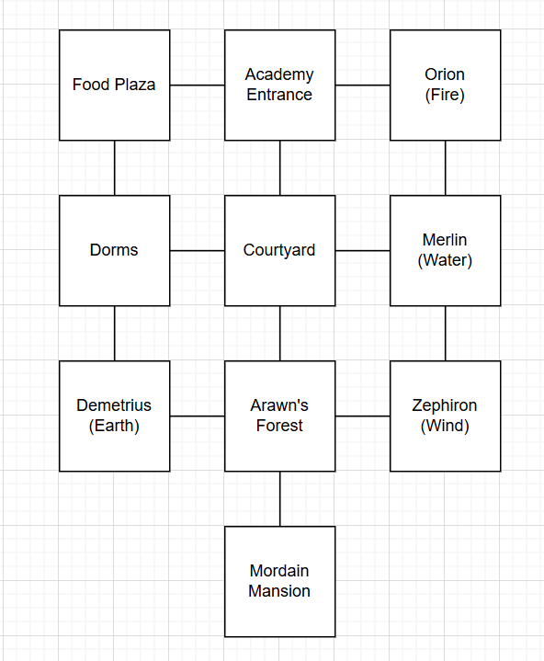
Map Designs:

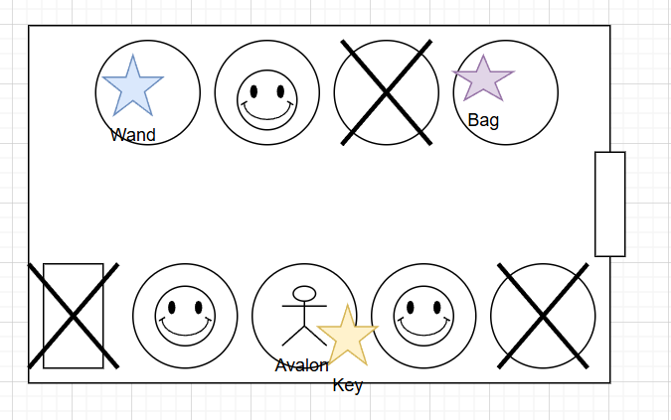 | Dorms:  Description: This is the Dorms. This is where you and your fellow classmates sleep and hang out. You are room 013  Items:  - “Key Card” Under your bed to enter buildings and your room  - “Wand” Used to cast spells  - “Bag” Carry your school stuff  - “Bed” A good place to rest for energy  Roommate NPC:  Events:  - Wake Up late for class  - Party Last night so you lost your stuff  - Talk to NPCs to find your stuff to leave for class
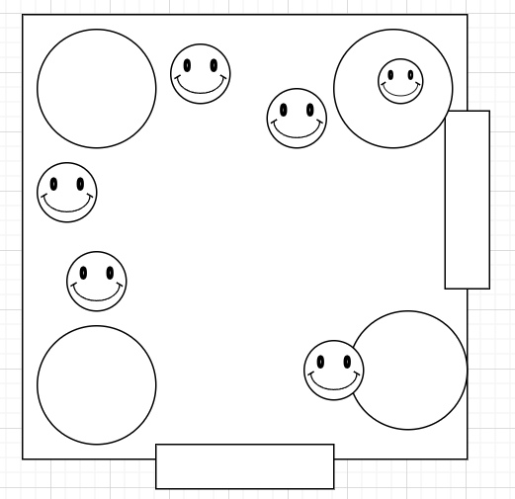 | Food Plaza:  Description: A place where people gather in masses for food. It’s a good place to talk to people and make some now friends!  Items:  - “Tacos” Food for Energy  - “Sandwiches” Food for Energy  - “Candle” Orion needed this  Random NPCs around the area
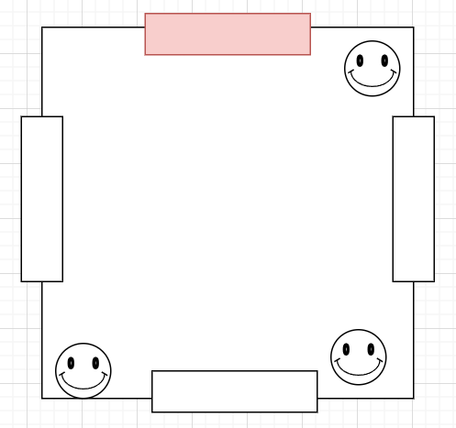 | Academy Entrance:  Description: This is the where you entered the Academy this past weekend. You left your parents here crying. I would love to go see them but I may end up not coming back to school  Roommate NPC:  Events:  - If the player tries to leave, the game will end with a loss  Random NPCs around the area
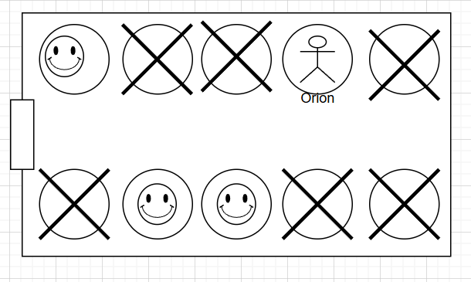 | Orion:  Description: This is the first place you will learn a spell. The fire spells.  Items:  - “Fire Scroll” needed to use fire spells  Orion NPC:  - He is happy to show you the ways of fire but he needs a candle to show you safely
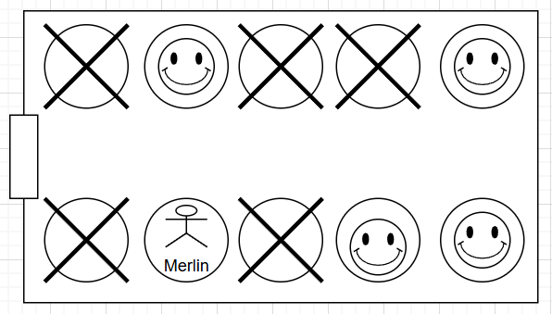 | Merlin:  Description: This is the second place you will learn a spell. The water spells. Requires the previous spell to enter the building  Items:  - “Water Scroll” needed to use water spells  Merlin NPC:  He is happy to show you the ways of water but it there will be some trial you need to go through to earn it
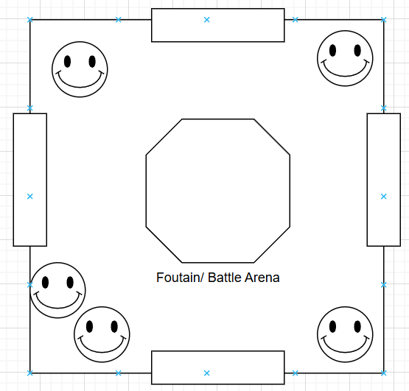 | Courtyard:  Description: The courtyard is in the center of the Academy. It has an academy map if you get lost. The fountain is a nice touch. You wonder how they have your final here.  Events:  - When you earn all 4 spells the final will take place here  - Use all spells to pass  Random NPCs
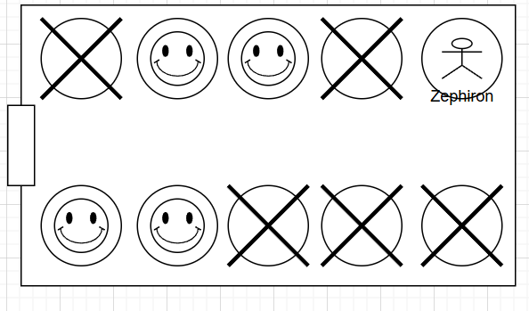 | Zephiron:  Description: This is the fourth place you will learn a spell. The wind spells. Requires the previous spells to enter the building  Items:  - “Wind Scroll” needed to use wind spells  Zephiron NPC:  He is happy to show you the ways of wind but it there will be some trial you need to go through to earn it
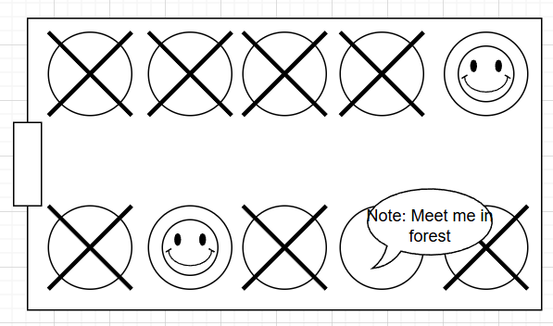 | Demetrius:  Description: This is the third place you will learn a spell. The earth spells. Requires the previous spells to enter the building  Items:  - “Note” that says that Demetrius is in the woods waiting for you
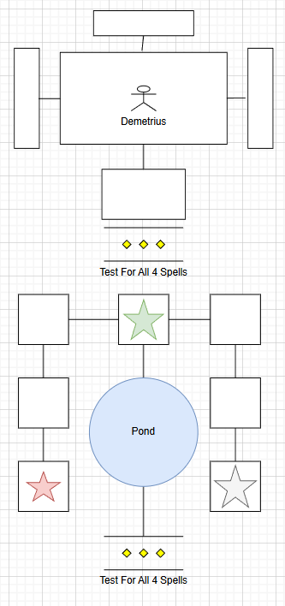 | Arawn’s Forest:  Description: This forest is named after the founder of the Academy. By a note you have been requested by Demetrius to meet him here.  Items:  - “Wind Scroll” needed to use wind spells  Demetrius NPC:  He is happy to show you the ways of wind but it there will be some trial you need to go through to earn it  Events:  - The player can find a secret path in the forest  - The pond leads to the Mansion but the play must explore and use all 4 spells to get across
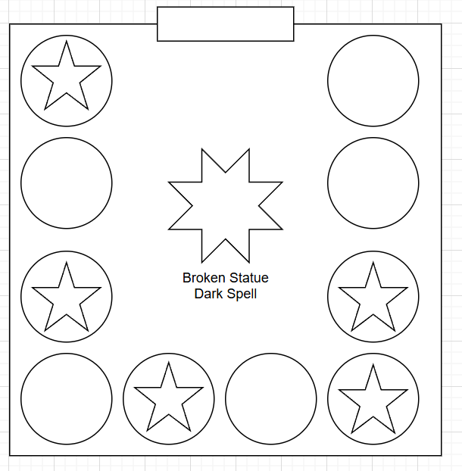 | Mordain Mansion:  Description: An old abandon mansion that used to belong to Mordain. Rumor around school is that he was killed by your teachers. I wonder if there is anything around here that could give you more information  Items:  - “Missing Gem 1/5” Used to fix the Statue  - “Missing Gem 2/5” Used to fix the Statue  - “Missing Gem 3/5” Used to fix the Statue  - “Missing Gem 4/5” Used to fix the Statue  - “Missing Gem 5/5” Used to fix the Statue  - “Dark Spell Book” Used to master Dark Magic

Play Items:
“Key Card” Under your bed to enter buildings and your room
“Wand” Used to cast spells
“Bag” Carry your school stuff
“Tacos” Food for Energy
“Sandwiches” Food for Energy
“Candle” Orion needed this
“Fire Scroll” needed to use fire spells
“Water Scroll” needed to use water spells
“Wind Scroll” needed to use wind spells
“Missing Gem 1/5” Used to fix the Statue
“Missing Gem 2/5” Used to fix the Statue
“Missing Gem 3/5” Used to fix the Statue
“Missing Gem 4/5” Used to fix the Statue
“Missing Gem 5/5” Used to fix the Statue
“Dark Spell Book” Used to master Dark Magic
“Earth Scroll” needed to use Earth spells

Non-Play Items:
“Bed” A good place to rest for energy
“Note” that says that Demetrius is in the woods waiting for you
“Fountain” A place to meet up with friends and where you take your final exam
“Statue” It is just a statue… Or is it!?!

